Graph is a data structure that consists of following two components:  
**1.** A finite set of vertices also called as nodes.  
**2.** A finite set of ordered pair of the form (u, v) called as edge

Graphs are used to represent many real-life applications: Graphs are used to represent networks

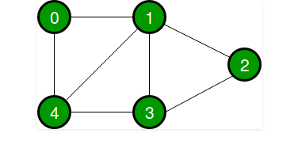

undirected graph with 5 vertices

Following two are the most commonly used representations of a graph.  
**1.** Adjacency Matrix-Adjacency Matrix is a 2D array of size V x V where V is the number of vertices in a graph

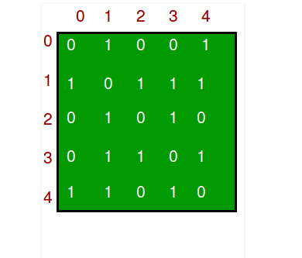

**Cons-** Consumes more space O(V^2). Even if the graph is sparse(contains less number of edges), it consumes the same space. Adding a vertex is O(V^2) time.  
**2.** Adjacency List -An array of lists is used. Size of the array is equal to the number of vertices

